**Problem 1: Read the instructions carefully and answer accordingly. If there is any need to insert some data then do that as well.**

**a) Navigate and List:**

**a. Start by navigating to your home directory and list its contents. Then, move into a directory named "LinuxAssignment" if it exists; otherwise, create it.**

Answer:-

I have used cd command to navigate it into home directory, Then i have used ls command to see which directoryies are present. As i dont have LinuxAssigment so i have created it using cd LinuxAssigment command.

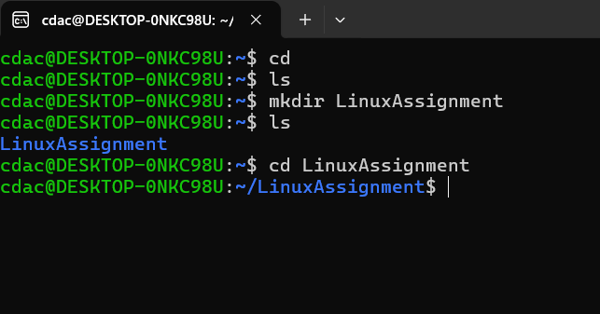

**b) File Management:**

**a. Inside the "LinuxAssignment" directory, create a new file named "file1.txt". Display its contents.**

Answer:-

to go into LinuxAssignment i have used cd LinuxAssignment command, Then i have created new file file1.txt using touch file1.txt command, to display its content i have to open that file into editor mode so i have write a comman called nano file1.txt, then with the help of echo i have written "I am learning Linux" and saved it. and to display it on command line i have used command called cat file1.txt.

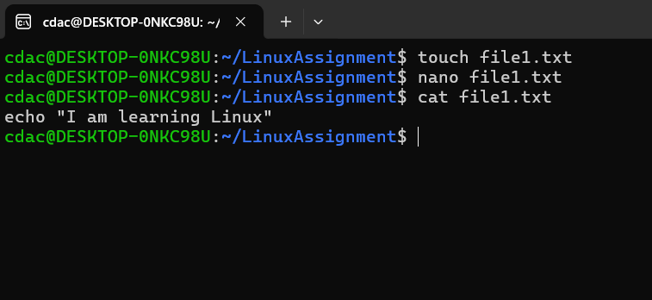

**c) Directory Management:**

**a. Create a new directory named "docs" inside the "LinuxAssignment" directory.**

Answer:-

To do this, first i have to go to the LinuxAssignment directory with the help of cd LinuxAssignment, Then to create new directory inside LinuxAssignment directory i have used cd docs and at last to check it is present in it or not i have used cd docs

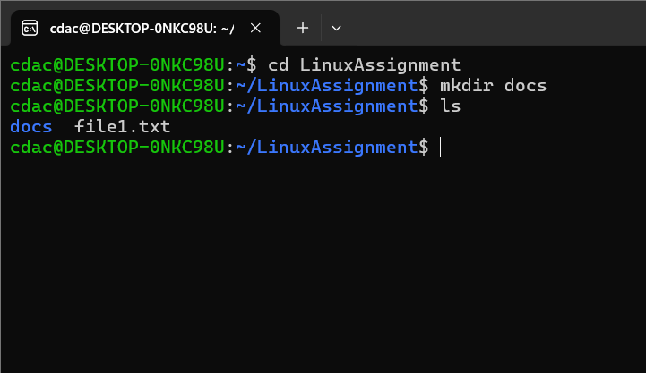

**d) Copy and Move Files:**

**a. Copy the "file1.txt" file into the "docs" directory and rename it to "file2.txt".**

Answer:-

to copy the file cp command is used so i have used the same like cp file1.txt docs/file2.txt, and to check whether it is worked or not i have used ls docs.

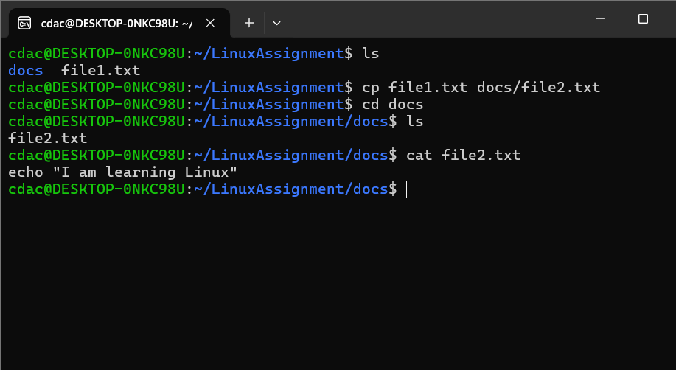

**e) Permissions and Ownership:**

**a. Change the permissions of "file2.txt" to allow read, write, and execute permissions for the owner and only read permissions for others. Then, change the owner of "file2.txt" to the current user.**

Answer:-

First, I navigated to the docs directory using cd docs Then, I executed the chmod 744 file2.txt command to give read, write, and execute permissions to the owner and read-only permissions to others to change the owner of "file2.txt" to the current user, I used the chown $(whoami) file2.txt command To check if the changes were successfully applied, I ran ls -l file2.txt

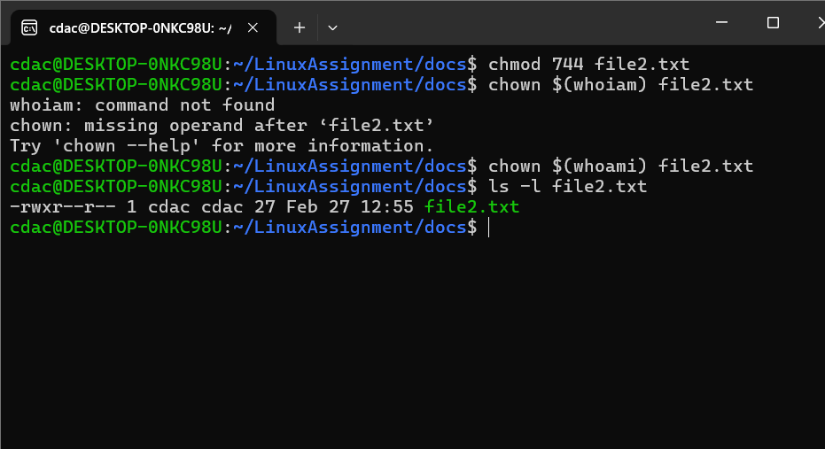

**f) Final Checklist:**

**a. Finally, list the contents of the "LinuxAssignment" directory and the root directory to ensure that all operations were performed correctly.**

Answer:

This command is used to check ls -l ~/LinuxAssignment

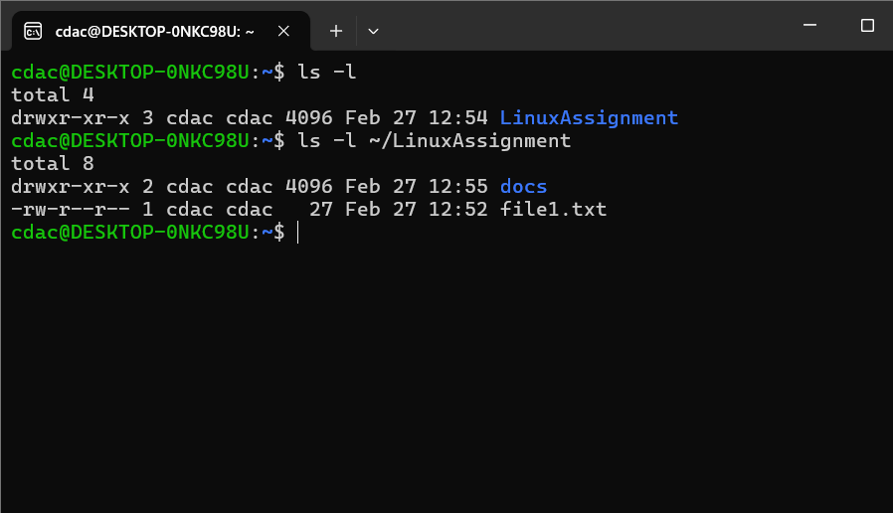

**g) File Searching:**

**a. Search for all files with the extension ".txt" in the current directory and its subdirectories.**

**b. Display lines containing a specific word in a file (provide a file name and the specific word to search).**

Answer:-

To find all .txt files inside the current directory find . -type f -name "*.txt" this command is used

and to find the word B-Tech i have used command called grep "B-Tech" file1.txt

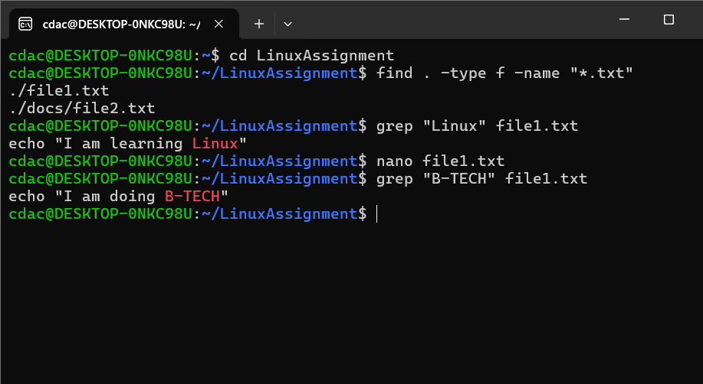

**h) System Information:**

**a. Display the current system date and time.**

Answer:-

To check it i have used a command called date

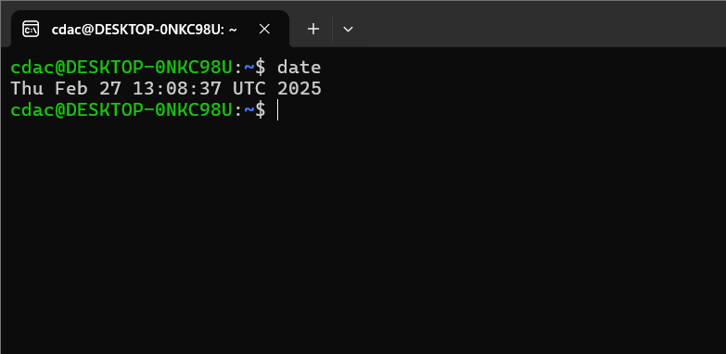

**i) Networking:**

**a. Display the IP address of the system.**

**b. Ping a remote server to check connectivity (provide a remote server address to ping).**

Answer:-

a) To check the IP address hostname -I this command is used

b) To check it i have used a command called ping -c 2 google.com, here ping send network packet to remote server -c 2 send only 2 packets.

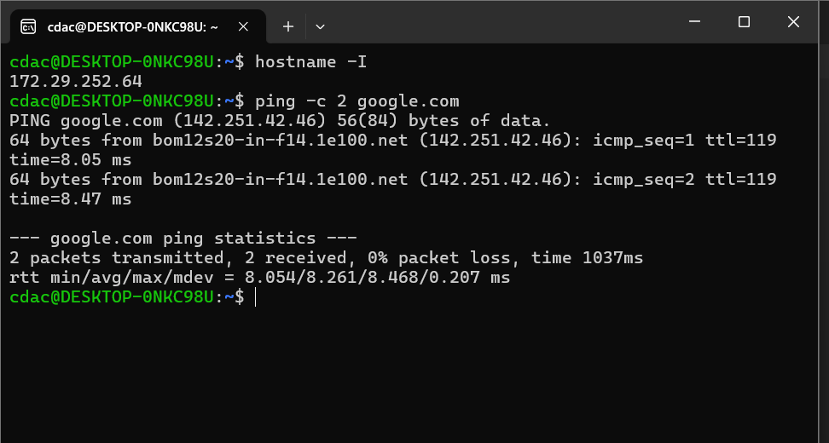

**j) File Compression:**

**a. Compress the "docs" directory into a zip file.**

**b. Extract the contents of the zip file into a new directory.**

Answer:-

zip -r docs.zip docs :- It will create docs.zip, which contains all files inside docs

unzip docs.zip -d new_docs :- it will extract the docs.zip file into new directory named newdocs.

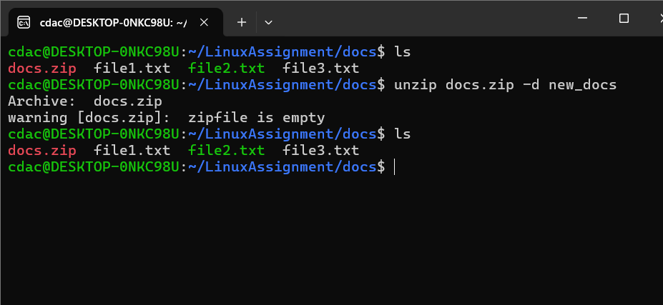

**k) File Editing:**

**a. Open the "file1.txt" file in a text editor and add some text to it.**

**b. Replace a specific word in the "file1.txt" file with another word (provide the original word and the word to replace it with).**

Answer:-

a) to open file1.txt in text editor we have to use nano file1.txt and to add some text in it we have to write echo "I am doing B-Tech".

b) to replace specific word i have to write something in editor so i have opened editor using nano file1.txt then with help of echo i have written "I am doing B-Tech" and saved it and came back in command line to replace the B-Tech with PG-DAC i have write a command called sed -i '/s/B-Tech/PG-DAC/g' file1.txt

